HW #7 Name: Jian Wang FSUID:JW09R

0. Executive Summary
. Value of European put calculated by C-N procedure for K=$10, r=$0.05/yr, =0.20/yr, T=0.5/yr with accuracy to nearest penny.
S | V | S | V | S | V
S=1 | 8.75 | S=2 | 7.75 | S=3 | 6.75
S=4 | 5.75 | S=5 | 4.75 | S=6 | 3.75
S=7 | 2.76 | S=8 | 1.80 | S=9 | 0.99
S=10 | 0.44 | S=11 | 0.16 | S=12 | 0.05
S=13 | 0.01 | S=14 | 0.00 | S=15 | 0.00
S=16 | 0.00 | S=17 | 0.00 | S=18 | 0.00
S=19 | 0.00 | S=20 | 0.00

In addition, if we choose S=8:
V=$1.80 (accurate to the nearest penny).
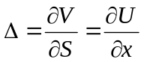=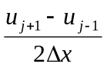=-0.908

- Statement of Problem

- Description of The Mathematics
First, we have already known the initial boundary value problem for the European put is:
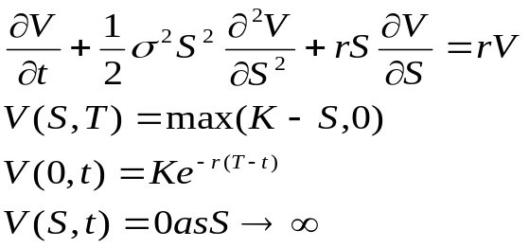
In order to solve this partial differential equation, we do the following transform:
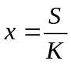, 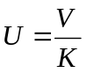, 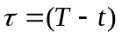, then we have equations:
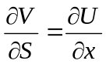, 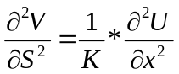, 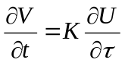
So the scaled IBVP is :
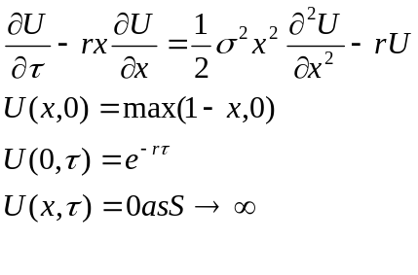
Second, we use Crank-Nicolson approximation to get the numerical solution of the problem. From previous we know how to approximate derivatives:
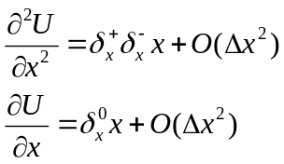
So : 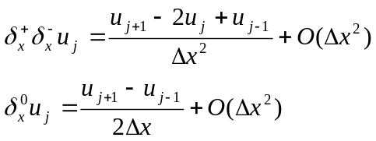
Then use Trapezoidal Rule to integrate through from 0 to T, we get following equations:
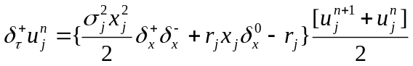
Where 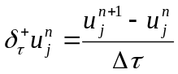
So we can represent the whole problem as:
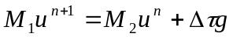
Where: 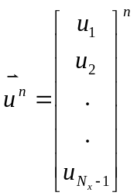, 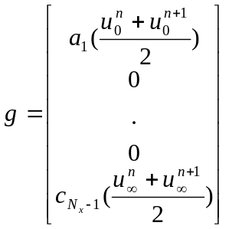
And:
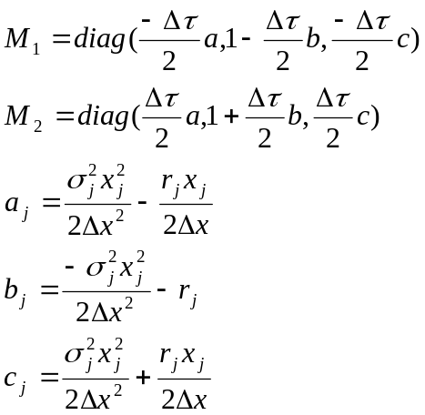

Third, we need to check the error, the method like the one we use in the Quadrature assignment. We choose two mesh with and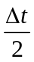. Then we have the following equations:
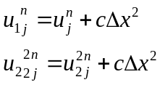
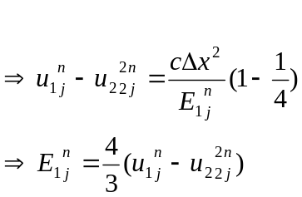

At last, in order to check the whole procedure, we have to solve a problem which we know the answer. If we add forcing term 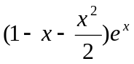to the right of the initial problem, and choose x from 0 to 2, from 0 to 1, 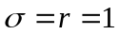. Then the exact solution of the following problem is 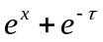
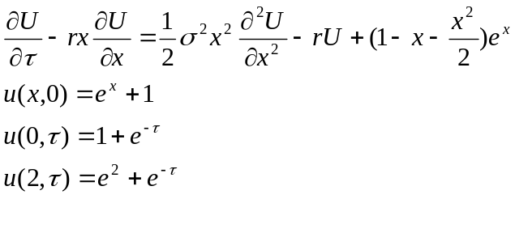

- Description of the Algorithm

- Results
1.
Value of European put calculated by C-N procedure for K=$10, r=$0.05/yr, =0.20/yr, T=0.5/yr with accuracy to nearest penny.
S | V | S | V | S | V
S=1 | 8.75 | S=2 | 7.75 | S=3 | 6.75
S=4 | 5.75 | S=5 | 4.75 | S=6 | 3.75
S=7 | 2.76 | S=8 | 1.80 | S=9 | 0.99
S=10 | 0.44 | S=11 | 0.16 | S=12 | 0.05
S=13 | 0.01 | S=14 | 0.00 | S=15 | 0.00
S=16 | 0.00 | S=17 | 0.00 | S=18 | 0.00
S=19 | 0.00 | S=20 | 0.00
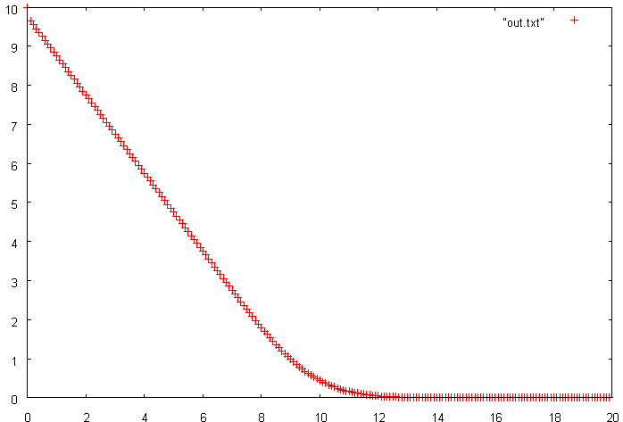

By running the procedure two times with 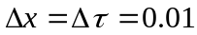 and 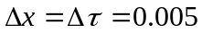, we can get the following output in which the absolute error was calculated by the equation 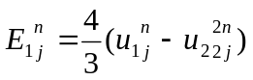. The output tells that the absolute error less than 0.001, so the output can be accurate to the nearest penny.
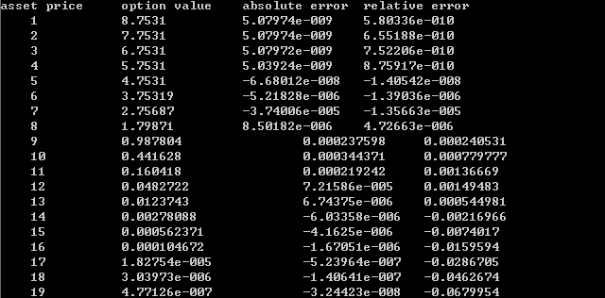

2.
Since , , then .
So choose S=8, V=$1.80 (accurate to the nearest penny).
==-0.908
3.
As in the last section, choose the point S=8 to calculate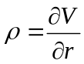
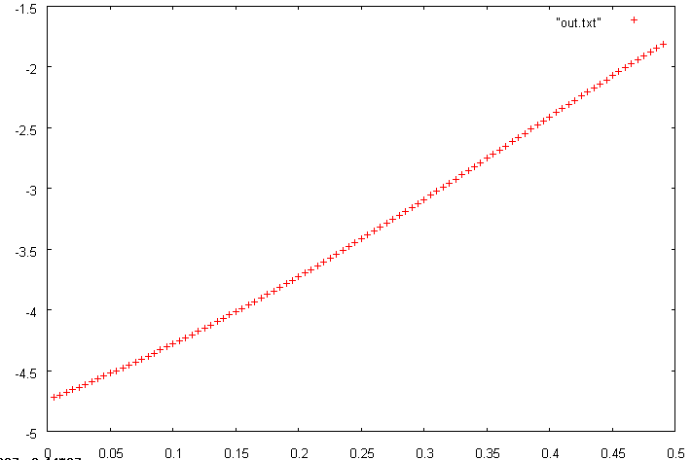
This is the graph of  value where R change from 0 to o.5.

- Conclusions
And choose x from 0 to 2, from 0 to 1,, then the exact solution will be . The theory tells us:
1. Error=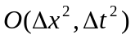. In this problem, since 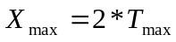, if we choose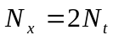, then 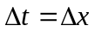 and the error calculated should be reduced to 1/100 when reduced to 1/10.
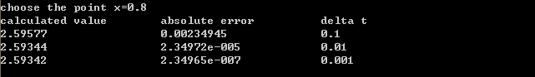
The absolute error is the numerical solution calculated by C-N procedure minus the exact solution at the point x=0.8. It follows the theory that when reduced to 1/10, the error reduced 1/100.

2. If we do the Crank-Nicholson procedure twice and choose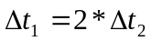. The error should satisfy the following equation
